1. Login

Access the management backend at 'http://ec2-18-183-32-51.ap-northeast-1.compute.amazonaws.com:82/' and enter your account credentials to log in. You can switch languages in the upper right corner of the page.

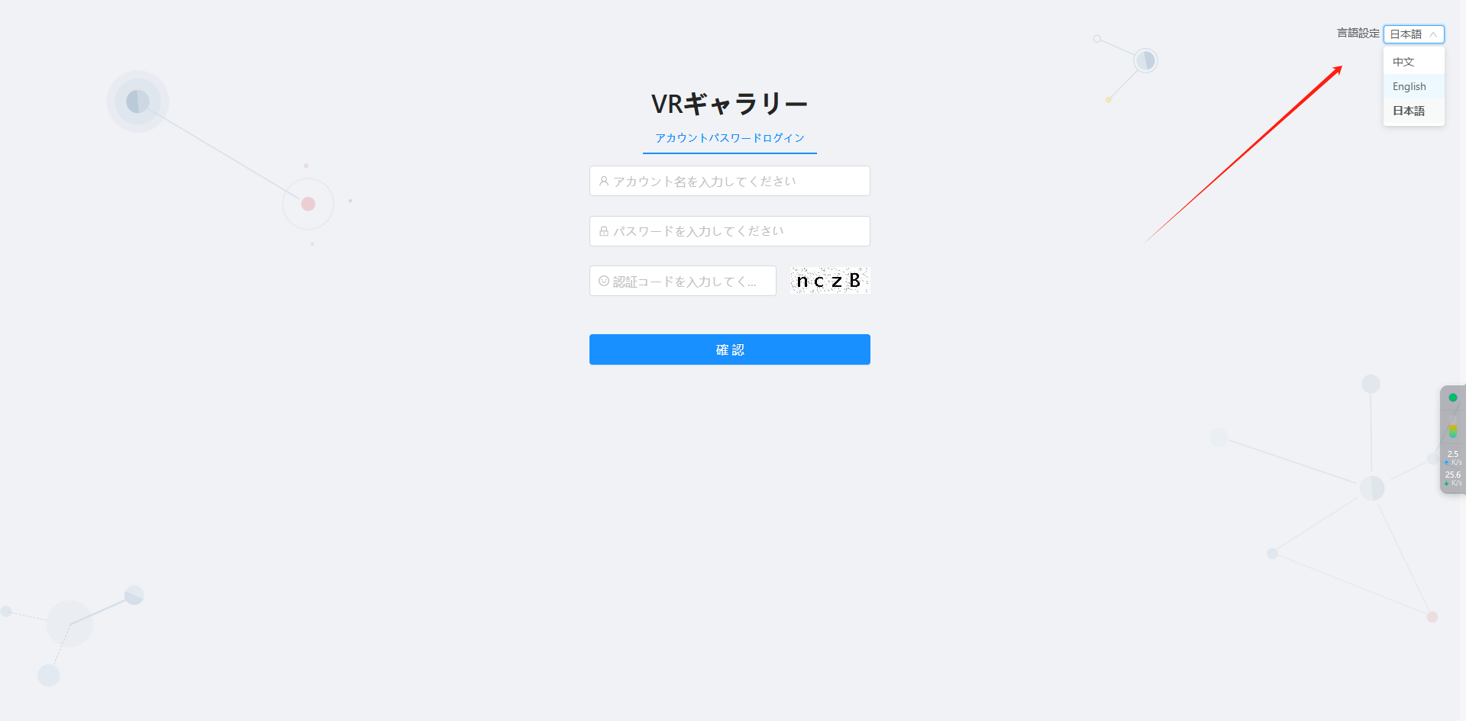

1. Manage APP

Log in to the operational account to access App management. Click the 'Add' button to create an APP, enter the APP name, and save to generate the APPID. Include this APPID when packaging on the APP side. Subsequently, you can update the APP by uploading the APP installation package through the editing function on the management side, along with the version number.

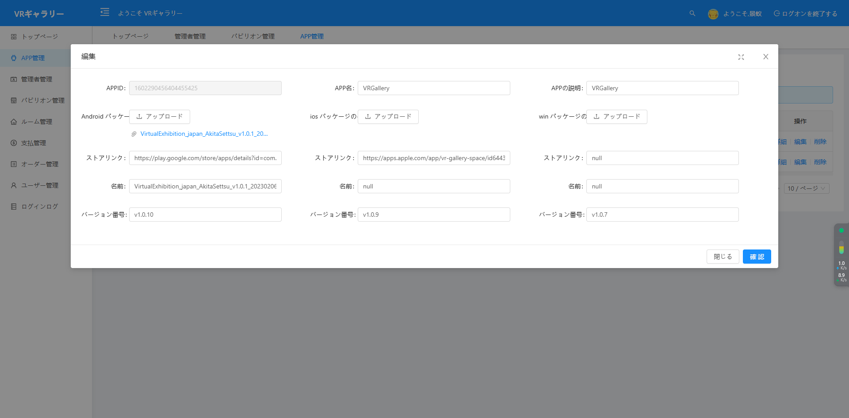

1. Create Exhibition Hall

Log in to the operational account, navigate to the exhibition hall management menu, and add or modify exhibition hall information. Each exhibition hall must be associated with an APP, and one APP can have multiple exhibition halls.

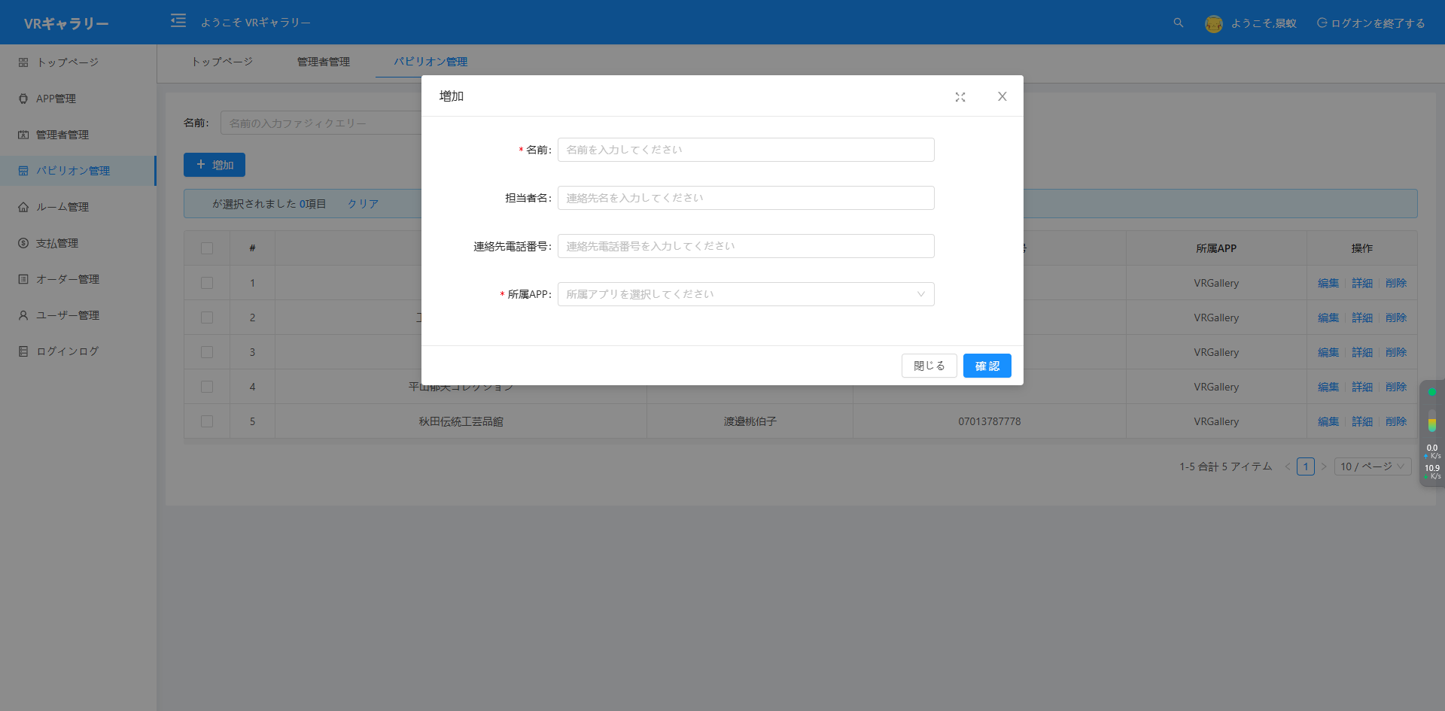

1. Exhibition Hall Administrator Management

Log in to the operational account, navigate to the administrator management menu, and create or modify exhibition hall administrator information. After creating an account, the exhibition hall administrator can log in to manage the rooms and exhibits of their associated exhibition hall. The current exhibition hall administrator account can be disabled through the freeze operation.

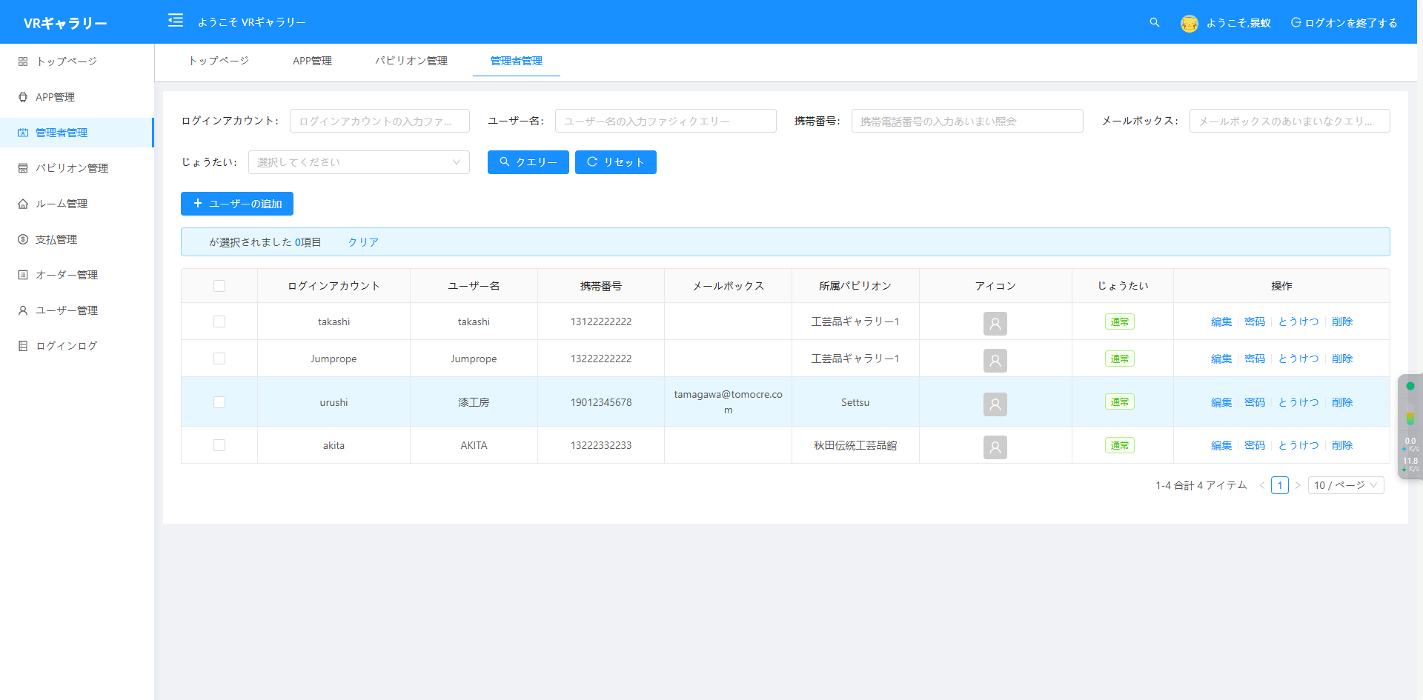

1. Create Room

In the room management menu, you can create exhibition hall rooms. Operational accounts have the ability to create and modify room information for any exhibition hall, while Exhibition Hall Administrators only have permissions to query, create, and modify rooms associated with their current account's exhibition hall.

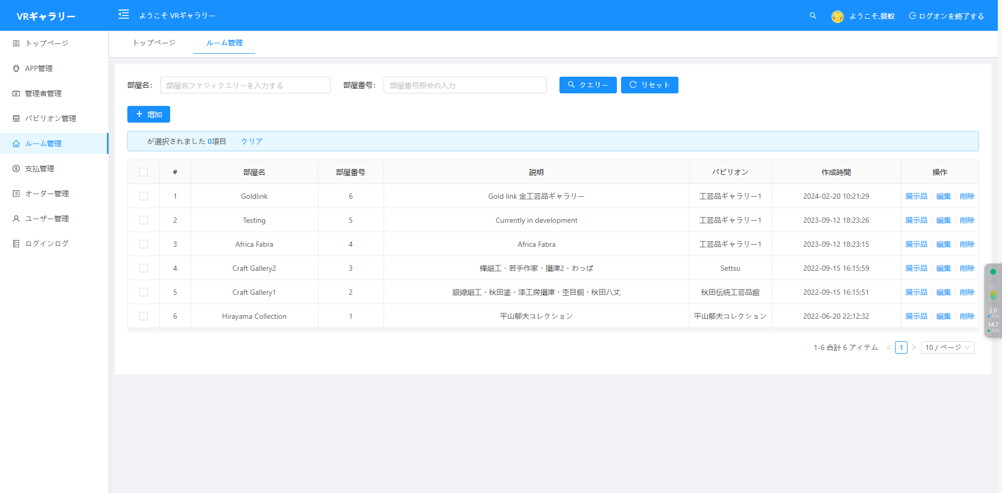

1. Maintain Exhibits in the Room

On the room management page, click the exhibit management button next to any room to view the list of exhibits currently in that room.

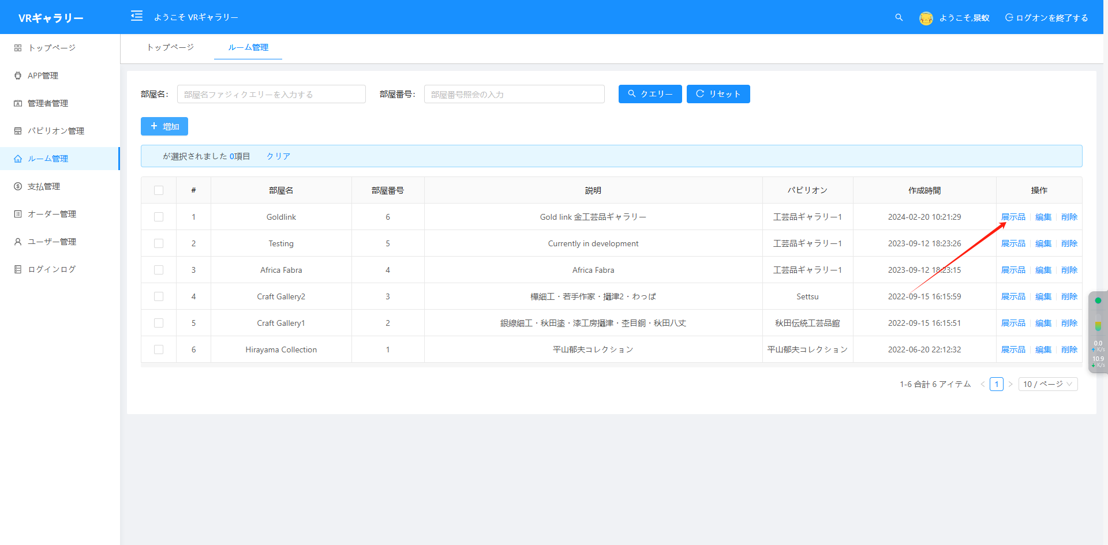

Add New: You can add the specified number of empty exhibit data rows.

Enable/Disable: Change the status of the exhibit; when disabled, the app will not display this exhibit.

VIP/Free: Change the permissions required to view the exhibit in the app. If it is a VIP exhibit, only users with VIP permissions can access it.

Upload BGM: Update the background music for the room.

Upload Resource Package: Update the scene resources within the room.

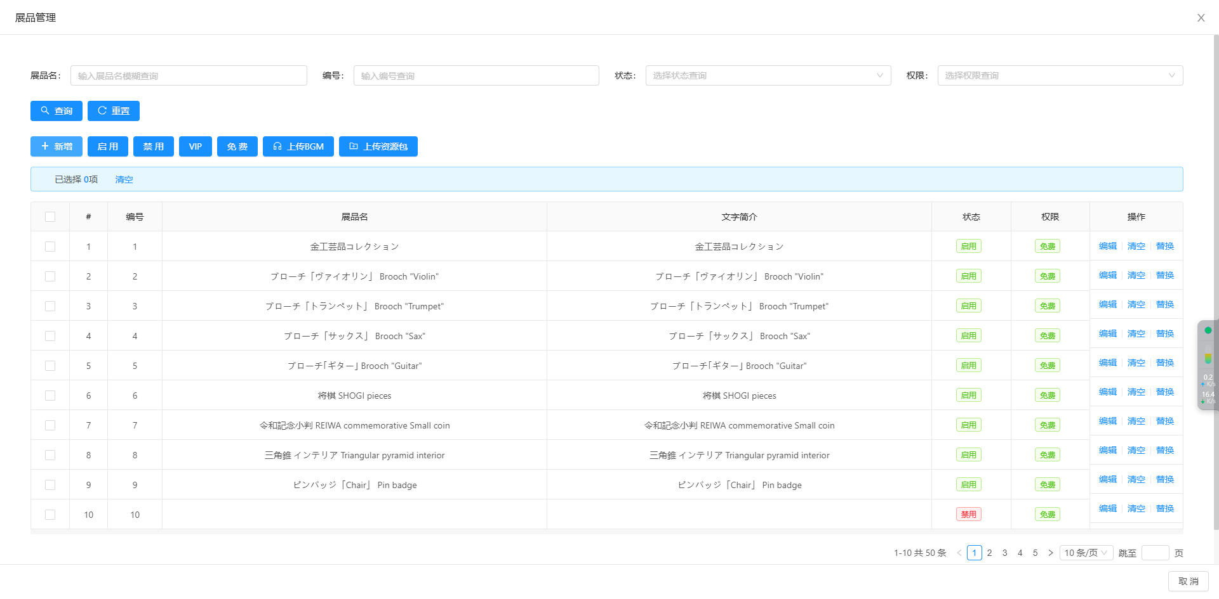

1. Payment Management

Log in to the operational account and navigate to the payment management page to configure the prices, discount codes, membership duration, and other information for VIP permissions in each exhibition hall.

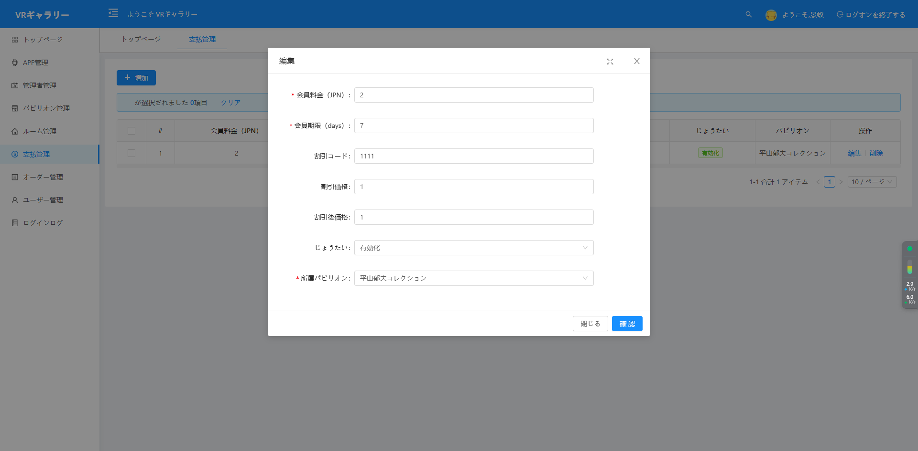

1. Order Management

Access the order management page to review the payment order status of members in each exhibition hall, with the option to export data.

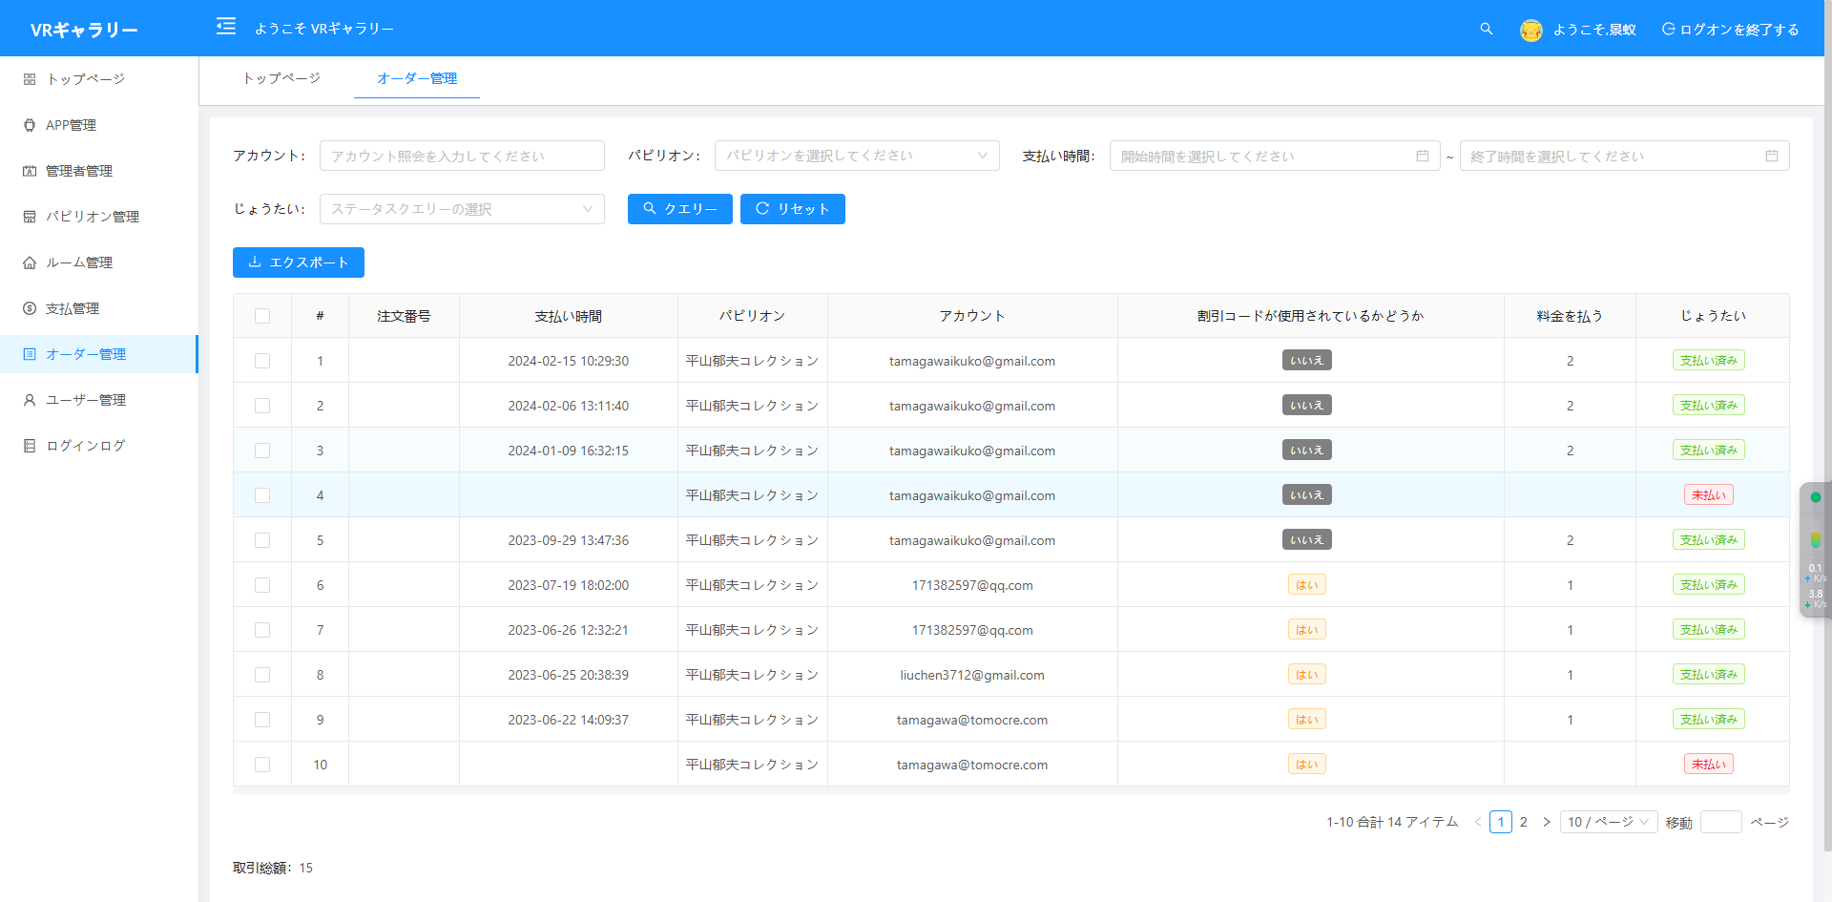

1. User Management

Navigate to the user management page to view all users registered in the APP. You can control whether users can log in to the APP by enabling or disabling their accounts. Click the permissions button to view the VIP expiration dates for users in each exhibition hall.  
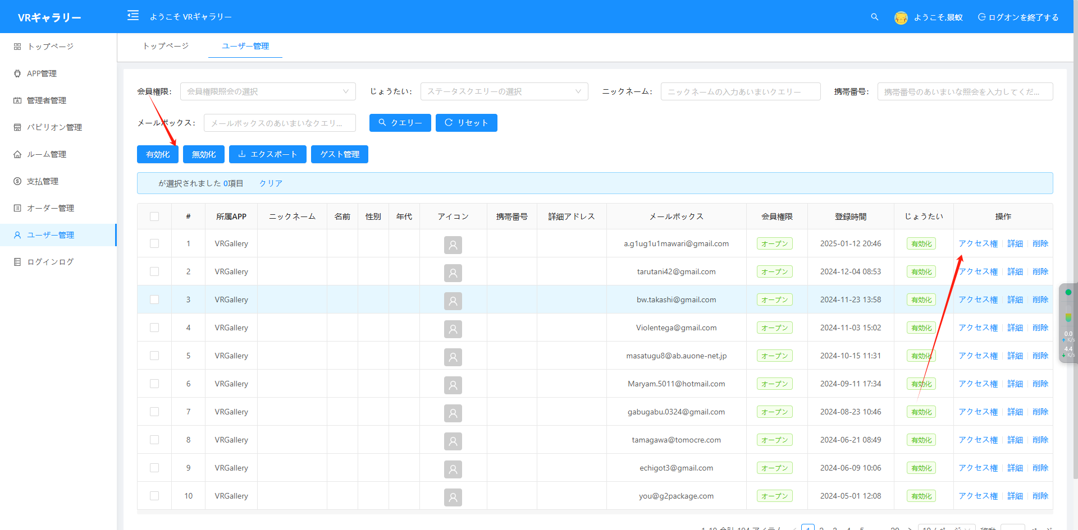

1. Login Log

Access the login log interface to review the login information of APP users. Click the view button to see the click statistics for each user.

